

Product Dissection for LinkedIn

# Company Overview:

LinkedIn is a social media platform that connects professionals to help them be more productive and successful. Founded in 2002 by Reid Hoffman and Eric Ly, LinkedIn has over 1 billion members in more than 200 countries and territories. LinkedIn generates revenue from membership subscriptions, advertising sales, and recruitment solutions.LinkedIn's mission is to "connect the world's professionals to make them more productive and successful". The company's vision is to “create economic opportunity for every professional”

# Product Dissection and Real-World Problems Solved by LinkedIn:

LinkedIn, a leading professional networking platform, offers a user-friendly interface for seamless navigation. Users find personalized content on their homepage, access key features through the navigation bar, and manage their profiles easily. The platform fosters professional connections through networking features like endorsements, recommendations, and event discovery.

Crucially, LinkedIn serves as a robust job search and recruitment platform. Job seekers benefit from personalized job recommendations and a comprehensive search engine, while recruiters leverage tools for talent acquisition and engagement. Content sharing and publishing enable users to showcase expertise and thought leadership while learning resources and skill assessments support continuous professional development.

Messaging features facilitate professional communication, and privacy settings ensure user data security. LinkedIn's commitment to innovation and user-centric design makes it a trusted platform for professionals worldwide to connect, learn, and grow in their careers.

# Case Study: Real-World Problems and LinkedIn's Innovative Solutions

In today's fast-paced professional landscape, individuals encounter various challenges in networking, career advancement, and skill development. Traditional methods of networking and job search often prove inadequate in meeting the evolving needs of professionals. Additionally, staying updated with industry trends and acquiring new skills can be daunting tasks.

# Problem 1: Limited Networking Opportunities

**Real-World Challenge**: Professionals often face challenges in expanding their professional network beyond traditional means, such as in-person events or referrals. Geographical constraints and access barriers can limit networking opportunities.

**LinkedIn's Solution**: LinkedIn provides a global platform for professionals to connect and collaborate, transcending geographical boundaries. Through advanced algorithms and personalized recommendations, LinkedIn suggests relevant connections based on users' profiles, interests, and industry relevance. This facilitates networking on a global scale, enabling professionals to build diverse networks and foster collaboration irrespective of location.

# Problem 2: Job Search Challenges

**Real-World Challenge**: Job seekers encounter difficulties in finding relevant job opportunities that match their skills, experience, and career goals. Traditional job search methods may not provide comprehensive or personalized job listings, leading to frustration and inefficiency.

**LinkedIn's Solution**: LinkedIn offers a comprehensive job search engine with advanced filters and personalized recommendations. Users receive tailored job alerts and notifications based on their profiles and preferences, streamlining the job search process. Additionally, employers and recruiters leverage LinkedIn's recruiting tools to post job openings, search for candidates, and engage with potential hires, enhancing the efficiency of the recruitment process for both parties.

# Problem 3: Skill Development Gap

**Real-World Challenge**: With rapidly evolving industries and technologies, professionals need to continuously update their skills to stay competitive in the job market. Accessing high-quality, relevant learning resources and opportunities for skill development can be limited or costly.

**LinkedIn's Solution**: LinkedIn Learning provides access to a vast library of online courses covering various topics and industries. Users can enhance their skills through self-paced learning, with courses ranging from technical skills to soft skills and leadership development. Additionally, LinkedIn offers skill assessment tests to validate users' proficiency in various skills, providing a tangible way for professionals to showcase their expertise to potential employers and advance in their careers.

# Problem 4: Ineffective Communication and Collaboration

**Real-World Challenge**: Professionals often struggle to communicate effectively and collaborate efficiently with colleagues, clients, and partners, especially in remote or distributed work environments. Inefficient communication channels and disjointed collaboration tools can hinder productivity and teamwork.

**LinkedIn's Solution**: LinkedIn provides messaging and communication features that facilitate professional conversations and collaborations. In addition to traditional messaging

functionalities, LinkedIn offers InMail, a premium messaging feature that allows users to send messages to anyone on the platform, facilitating outreach and networking. Furthermore, LinkedIn Groups enable users to engage in group discussions and collaborations within specific interest areas or industries, fostering knowledge-sharing and community-building among members.

**Conclusion:**

LinkedIn's innovative solutions address a range of real-world challenges faced by professionals, including limited networking opportunities, job search difficulties, skill development gaps, and ineffective communication. By providing a comprehensive platform for networking, career advancement, learning, and collaboration, LinkedIn empowers individuals worldwide to thrive in the modern workforce landscape.

# Top Features of linked:

1. **Profile Creation and Management:** Users can create detailed profiles highlighting their work experience, skills, education, and recommendations. They can manage and update their profiles to reflect career milestones and achievements.
2. **Networking Tools:** LinkedIn facilitates professional networking through features like connections, endorsements, and recommendations. Users can connect with colleagues, industry peers, and potential employers to expand their professional network.
3. **Job Search and Recruitment:** LinkedIn offers a comprehensive job search engine with advanced filters and personalized job recommendations. Job seekers can apply to job postings directly through the platform, while recruiters can use LinkedIn's recruiting tools to search for candidates and post job openings.
4. **Content Sharing and Publishing:** Users can share updates, articles, and multimedia content with their network, showcasing their expertise and thought leadership. LinkedIn's publishing platform allows users to write and publish long-form articles, establishing themselves as industry thought leaders.
5. **LinkedIn Learning:** LinkedIn Learning provides access to a vast library of online courses covering various topics and industries. Users can enhance their skills and stay competitive in the job market through self-paced learning and skill development.
6. **Messaging and Communication:** LinkedIn's messaging feature allows users to communicate privately with their connections. Users can initiate conversations, exchange information, and explore collaboration opportunities with colleagues and peers.
7. **Groups and Communities:** LinkedIn Groups enable users to join communities based on shared interests, industries, or professions. Groups facilitate discussions, knowledge-sharing, and networking opportunities among members.

# Schema Description:

The schema for LinkedIn involves multiple entities that represent different aspects of the platform. These entities include Users, Posts, Comments, Likes, Connections, Messages, and more. Each entity has specific attributes that describe its properties and relationships with other entities.

### Users Entity:

* + **UserID**: **(Primary Key)** A unique identifier for each user.
  + **Username**: The chosen username for the user's account.
  + **Email**: The user's email address for account-related communication
  + **Password**: The user's password for account authentication.
  + **DateJoined**: The date when the user joined the platform.

### Posts Entity:

* + **PostID**: **(Primary Key)** A unique identifier for each post.
  + **UserID**: **(Foreign Key referencing Users Entity)** The identifier of the user who created the post.
  + **Content**: The content of the post.
  + **Timestamp**: The date and time when the post was created.

### Comments Entity:

* + **CommentID: (Primary Key)** A unique identifier for each comment.
  + **PostID**: **(Foreign Key referencing Posts Entity)** The identifier of the post to which the comment belongs.
  + **UserID**: **(Foreign Key referencing Users Entity)** The identifier of the user who posted the comment.
  + **Content**: The content of the comment.
  + **Timestamp**: The date and time when the comment was posted.

### Likes Entity:

●

* + **LikeID**: **(Primary Key)** A unique identifier for each like.
  + **PostID**: **(Foreign Key referencing Posts Entity)**The identifier of the post that was liked.
  + **UserID**: **(Foreign Key referencing Users Entity )** The identifier of the user who liked the post.
  + **Timestamp**: The date and time when the like was made.

### Connections Entity:

* + **ConnectionID**: **(Primary Key)** A unique identifier for each connection.
  + **User1ID**: **(Foreign Key referencing Users Entity)** The identifier of one user in the connection.
  + **User2ID**: **(Foreign Key referencing Users Entity )** The identifier of the other user in the connection.
  + **ConnectionStatus:** The status of the connection (e.g., pending, accepted, declined).

### Messages Entity:

* + **MessageID: (Primary Key)** A unique identifier for each message.
  + **SenderID**: **(Foreign Key referencing Users Entity )** The identifier of the user who sent the message.
  + **ReceiverID**: **(Foreign Key referencing Users Entity )** The identifier of the user who received the message.
  + **Content**: The content of the message.
  + **Timestamp**: The date and time when the message was sent.

### Skills Entity:

●

* + **SkillID: (Primary Key)** A unique identifier for each skill.
  + **SkillName**: The name or title of the skill.

### Share Entity:

**●**

* + **ShareID: (Primary Key)** A unique identifier for each share.
  + **PostID**: **(Foreign Key referencing Posts Entity)** The identifier of the post that was shared.
  + **UserID**: **(Foreign Key referencing Users Entity )** The identifier of the user who shared the post.
  + **Timestamp**: The date and time when the post was shared.

### Experience Entity:

* + **ExperienceID**: **(Primary Key)** A unique identifier for each experience.
  + **UserID**: **(Foreign Key referencing Users Entity)** The identifier of the user who has the experience.
  + **Title**: The title or position in the experience.
  + **CompanyName**: The name of the company where the experience was gained.
  + **Location**: The location of the company.
  + **StartDate**: The start date of the experience.
  + **EndDate**: The end date of the experience (nullable).

### Groups Entity:

* + **GroupID**: **(Primary Key)** A unique identifier for each group.
  + **GroupName**: The name of the group.
  + **Description:** A brief description of the group.
  + **CreatorID**: The identifier of the user who created the group (Foreign Key

### referencing Users Entity).

* + **CreatedDate**: The date when the group was created.

**Relationships are:**

### Users and Posts:

One-to-Many relationship: Each user can create multiple posts.

### Posts and Comments:

One-to-Many relationship: Each post can have multiple comments.

### Posts and Likes:

One-to-Many relationship: Each post can have multiple likes.

### Users and Connections:

One-to-Many relationship: Each user can have multiple connections.

### Users and Messages:

One-to-Many relationship: Each user can send and receive multiple messages.

### Users and Shares:

One-to-Many relationship: Each user can share multiple posts.

### Users and Experience:

One-to-Many relationship: Each user can have multiple work experiences.

### Groups and Users:

One-to-Many relationship: Each group can have multiple users.

## ER Diagram:

Let's construct an ER diagram that vividly portrays the relationships and attributes of the entities within the LinkedIn schema. This ER diagram will serve as a visual representation, shedding light on the pivotal components of LinkedIn's data model. By employing this diagram, you'll gain a clearer grasp of the intricate interactions and connections that define the platform's dynamics.

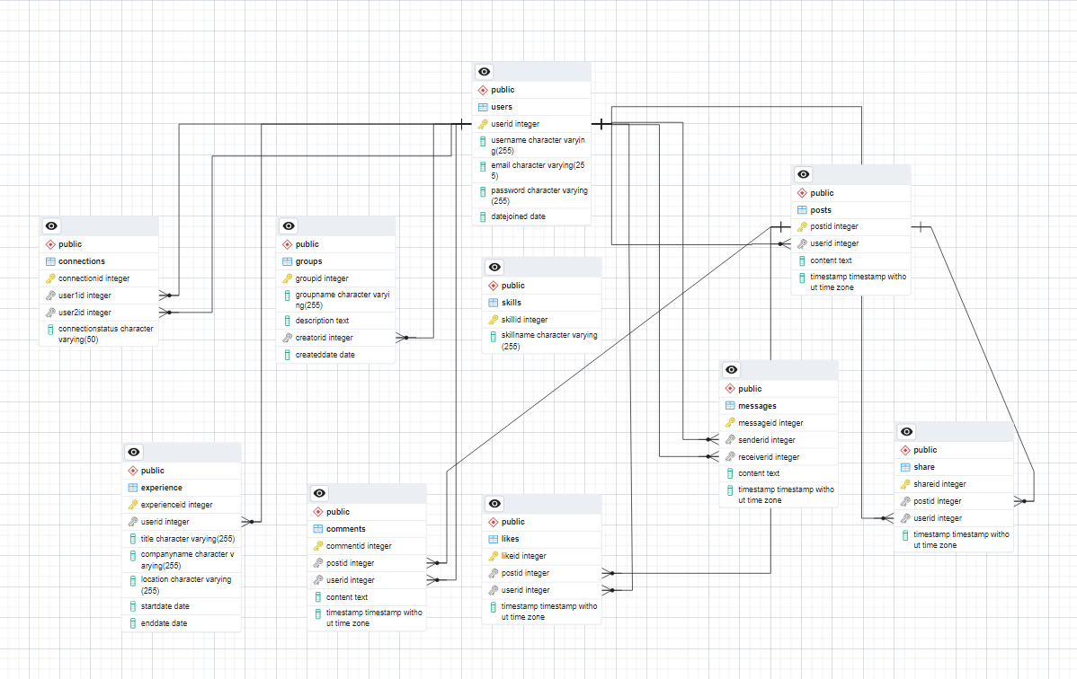

# Conclusion

the case study delved into the real-world problems faced by users in networking and professional engagement, emphasizing the need for innovative solutions. LinkedIn emerged as a transformative platform, reinventing networking dynamics by providing a robust ecosystem for professionals to connect, share insights, and advance their careers. Through its core features, functionalities, and user interactions, LinkedIn addresses key challenges such as networking limitations, job search inefficiencies, and skills development gaps. By fostering meaningful connections, facilitating knowledge exchange, and offering valuable resources, LinkedIn continues to empower individuals and organizations worldwide, reshaping the landscape of professional networking and career development.